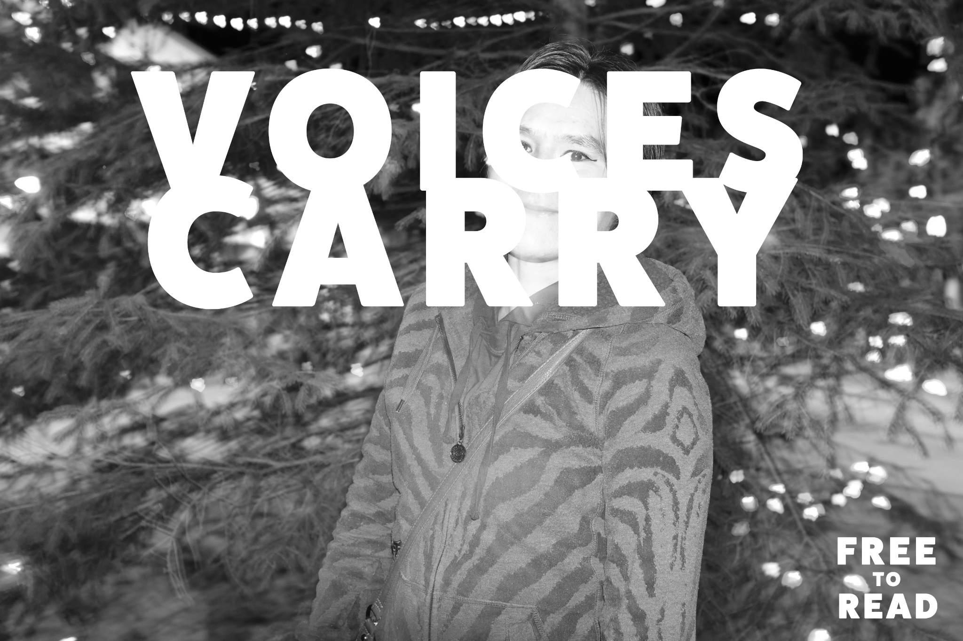

Warren ‘Warren Dubz’ Wilson
32 years old
Smithers / Bulkley Valley (born and raised)
Poverty and addiction keeps him here
He moved away for 2-3 years, and as a result of divorce, loss of family and support, he moved back last summer. It wasn’t planned. It’s what happened.
He describes himself as “totally corrupted”.

Warren and I sat down in December of 2023 to talk after he picked a flower from a table centerpiece arrangement and gave it to me.

Pam Haasen - You are a wordsmith, and a musician, right?

Warren Dubz - Yeah, I wrote a song when I was in jail, it got rained on, written on paper and lost it. Had to start all over again on the first song I’d written in a long time. I couldn’t bring myself to try again until recently after that. But I can freestyle just as good as I can write now.
It’s still a part of me, but it’s taken a backseat.

PH - Was making art a luxury or necessity?

WD - Yeah it was, especially in recovery, a necessity. It was a good outlet for releasing, you know, anger, stress, fears, putting things into perspective or, you know, helping me dream a bit and talk about where I want to go with this and where I hope to be in the next five years, if I’m still alive, God willing, you know, but I don't know.
And then it started to become something like, I started being able to be a voice of the community, a voice of the people. A voice of the people who didn't have a voice. Kind of told our story and grim tale of our lifestyle and journey and, you know, what we were going through at that time.
PH - So I think it sounds like art is almost therapy for you. And when people hear words that speak to them as well, it lights something up inside of them. So, in a lot of ways, like, by you creating and making your music and sharing your music, you're kind of, you're doing a service to people that maybe can't find those words inside themselves.
WD Yeah, I guess so. I don't know. There's only a few people who actually express to me that I did inspire and motivate them. And then, I get reactions like I did with you, like, “Oh, you're Warren Dubz!” I get that every now and then, not as much as I had hoped.
Yeah. But when that does happen, it is awesome. It is.

PH - Okay, what excites you?

WD - What excites me? Not a whole lot of things these days, you know? I do enjoy a good landscape portrait. Nice backdrop. Beautiful sunrise, sunset kind of thing. I do enjoy live music. Good singing, carrying notes, that kind of thing. You know, I try to focus on the finer things in beauty and life. Because my life is so dark, lonely, grim, hideous, and full of hatred and anger and violence that those little things, those tiny little things that I just mentioned, things, simple things, you know, they really do help and help me get through the day and through the week and, you know, even through the moment in time that I'm going through.
I like seeing … somebody marvel at something.
You know, people adore each other. Your child being just so thrilled that they were able to do the simplest thing, like drawing a circle.

You know, seeing them full of life and things like that. Catching your loved one off guard with something that they told you a long time ago and didn't expect you to remember, and just having it be like the ultimate gesture kind of thing. Yeah. Yeah. Those things excite me.
Nothing else really does.

PH I mean, I think that that's a beautiful list, and those are really those kind of intangible things that you're describing–

WD - Like Okay. A bottle of whiskey would excite me too. Okay. Like, really, really super excites me and gest me switched on, but I didn't want to say that until the end. (Laughing)

PH - So we all change and grow as we get older. What change do you feel occurring within you as you get older? Like, for me, I've learned that I'm trying, it's not easy, but I've been trying to be more forgiving and more patient. And I feel like every year that I try that I do get a little bit better at it, but it's not necessarily in my nature. What about you?

WD - I'm like, I'm like the spoiled prince. Trying to be a king of a nation. That's just an example. And, uh, yeah, I started off doing it wrong. You know, because I was “Mr. Sobriety” and “Mr. Hip Hop” and Mr… you know, “Performing Artist” and you know, “Sober First Nation Man”, blah, blah, blah, and I had all these accolades and titles and people insisted I was this leader and this whole other thing that I definitely wasn't ready for.
And with that power still I was leading people in the wrong direction. I felt like I was, you know, going the wrong way. Like I said, like a Spoiled Prince instead of a noble King. So now I have a lot more understanding, compassion. I feel like I have a lot more of the right message to send and right things to say in the moment.
So yeah, like, to answer your question. Yeah. I find As I get older, I'm becoming more, well, obviously wiser and mature, a tidbit. I'm not that mature (laughing). I'm actually least mature in a social setting, especially when it's awkward. I'm like the most impossible person to be around. (Chuckles loudly)

PH - Well, it's funny because you kind of come on strong, but
is that, like a way of deflecting so that people might not approach you as much because they think, ‘Oh, that guy might be too much for me’ or something like that?
Like a mechanism to sort of protect yourself? Or do you just like to see people react?

WD - I have no idea. It's more for me than anybody.

PH - Who else to do it for?

WD - I see a pretty girl or somebody with a characteristic trait or something that would, uh, be noticeable to me… I can't help myself. I have no control over it.
It just, you know, it does what it does. I don't know how else to explain it.

PH- Do you have siblings?

WD - Uh, I have four siblings.

PH - Are you the middle?

WD - I am actually.

PH - Because you got middle child syndrome. Has anyone ever told you that?

WD - Really?

PH - Yeah.

WD - Like wanting attention, kind of like, “hey look at me”? Like banging the pot and pan on the head and stuff?

PH - I'm a middle child too, which is why I recognize it.

WD - Hmm, you're the first person that’s ever told me that!

PH - Wow. Yeah, you got hard. You got M C S.

WD - Oh my god. That's what that's called. I had no idea! (Laughing) I knew I was really a little extra and over the top kind of, but…

PH - If you ever want to change your name as a rapper, maybe try Middle Child. Just consider it, I'm just throwing it out there.

WD - Instead of Mad Child, Middle Child. Oh yeah! there we go!

PH - Yeah, okay, I'm interviewing you to kind of get to know you and then this is going to be, like, either shared or not shared.
It's going to be something that people can pick up and read, right? Anyone can pick up and read. What's something that you want people in this town to know about you?

WD - Just let them, I just want them to know that I'm real. I was never trying to be something I wasn't. You know, I didn't do anything that was unnecessary. If I was good, it was a necessary good. If I was evil, it was a necessary evil. You know, and violent or non violent and so forth. You know, I never just acted on a whim or did anything that would jeopardize anybody else unless it was just myself, right?
And I only behaved accordingly. I wasn't treated with the same mercy or understanding or, you know, necessary or unnecessary good and evil, but I'm still here and I just want them to know that I wasn't out to try to hurt anybody or, you know, to become a bad person like I'm perceived as being.
Well, my last album was titled ‘The Villain’.

PH - Oh, yeah?

WD - Yeah, it's actually pretty good.

PH - Is that who you were when you wrote it, or was that kind of like an alter ego?

WD - That's where it started, actually. And, it progressed and got worse, and not on purpose, just trying to protect, you know, the underdogs, the homeless, the, the, the addicts, the, the people that didn't have someone to stand and fight for them or have a voice for them, you know what I mean? I became that crazy lunatic that prevented people from trying to come, you know, harass and assault them for no reason.

PH - Yeah, but that sounds exhausting

WD - For all seriousness, like, I don't know. It's basically what I am in this town, and it wasn't easy filling the shoes of my father, cause he was the town tough guy before I was.
And he was much more than I am, like a much more established person and a lot more physically menacing and stronger and all these things. And he put his time in long before I did and then he passed away and then left the mantle to me. And I was not ready for it at all. I was left with no choice. Yeah, picked up that torch and ran with it, you know?

And, uh, I don't know. Like I said, I became a lot of the wrong things in the beginning. But I feel like at this point I have a lot better direction and a better message and love for the people. Because I didn’t…They made me feel so fucking unloved and secluded and, you know, alienated.

And I acted out on that and that helped the villain become the villain even more. And it was weird because on the same day that crazy things would happen or crazy things that I did, I would write and record a song the same night and we'd listen to it at a party and be like, “that just happened!”

You know, it made it so much more legit and then, you know, I had a falling out with the producer of the album and my best friend…And then we didn't complete the album, but we got like 14 tracks deep and then that was it.

I don't know, just the whole villain-y thing just kept going and getting worse and worse. It's kind of like if you take a slight step to the left in the wrong direction, you, after, you know, your first incident or, you know, whatever happens, you gotta keep slightly going to, in that wrong direction, you know, to keep yourself safe, to, to protect other people, to, I don't know, do whatever, you know, like, it just becomes your life, and you just get further and further and further and further.
And, uh, before you know it…you’re just the town devil.

It’s December 8th, 2023 at the Salvation Army in Smithers. I’m here for a free turkey dinner and to sit and talk with friends.
Behind Warren and I (on the recording), a group of people are singing Christmas carols. Right now they are singing Silent Night and Warren stops talking for a moment to gather his thoughts.

PH - Is there anything that you want people to know about you that you think that they don't? Or if there's something that's misunderstood that you want to clear up?

Warren seems exhausted now, and thinks for a moment before answering quietly.

WD - I don't know. I guess, uh, at this point I really do have middle child syndrome.
I am a little bit loud and a little bit extra and all this. And, I'm not as bad as they think I am. Actually, if you get to know me, I'm actually pretty funny, you know, a little sensitive, kind of a sweetheart, blah blah blah, all that bullshit, you know.

I've only become bad because I did bad things because that's what I had to do. Not because I wanted to. I just want them to know that, uh, I'll never give up on them. The Bulkley Valley, you know. I'll always love this place and its people but sometimes I just want to whip their ass. Because they need it.

If you want a sample of Warren’s work - you can still find his CICK Lounge Car Session on YouTube. Search ‘CICK Smithers Community Radio Lounge Car session Warren Dubz’.

With his permission, I’m sharing the lyrics to a song Warren wrote and performed live at CICK in 2018.

It’s called Crazy Little Rapper

Warren Dubz
Check me out
Overcome your fear man
Life goes on
You always stress about the things that might go wrong
Like Michails gone
Keep your love close to you
Enemies don’t live forever
Neither will you
So enjoy life, now even better
Than the last fool did
Best she’s ever had
Not saying I’m never mad
Not saying I’m never glad
But we’ve been through the storms
In the last couple of years
My worst decision was just have a couple beers
I’m an addict so I didn’t stop after “just two”
The decisions I make while drinking
Is what makes it so hard to just “trust you”
Just you, Dubz
Just you and your sick thoughts
Thinking like a crazy little rapper in hip hop.
Thinking like a bank robber
Trying not to get shot
Thinking like Canada’s most
Not to get caught
If I get caught slippin
Then I’m Failure Face
It would disgrace my race
You wouldn’t trade your place
To walk in my shoes
For an era minute
Turn the beat down now
Let us pray for a minute
Thank you god for life
For the gifts I possess
And over time groomed
In myself to the best
Like the underrated, underpaid and overworked,
Never see the appreciation or the silver perks
But we keep lunging forward
One day at a time
I pray out loud too
But mostly pray in my mind
Sometimes on my hands and knees
Beggin for mercy
Of a loving God that always makes me feel worthy
After all I’ve been through, my God he has my back
I’ve cursed, I’ve sinned too, he forgave me for that
I used to look to this world
Often say “screw you”
But there’s too much of that already
I just love you
It’s just you, Dubz
Just you and your sick thoughts
Thinking like a crazy little rapper in hip hop.
Thinking like a bank robber
Trying not to get shot
Thinking like Canada’s most
Not to get caught
It’s just you, Dubz
Just you and your sick thoughts
Thinking like a crazy little rapper in hip hop.
Thinking like a bank robber
Trying not to get shot
Thinking like Canada’s most
Not to get caught
It’s just you
It’s just you
It’s just you
It’s just you
Who can make choices for a better tomorrow?
It’s just you
It’s just you
Who can control your emotions on a daily basis
It’s just you

Wayne ‘Gunner’ Suvee
50 years old
From Burns Lake
Moved to Smithers with his mom when he was 8
Stayed here ever since
Favourite music:
ACDC, Johnny Cash, Kris Kristofferson, and Steve Earl

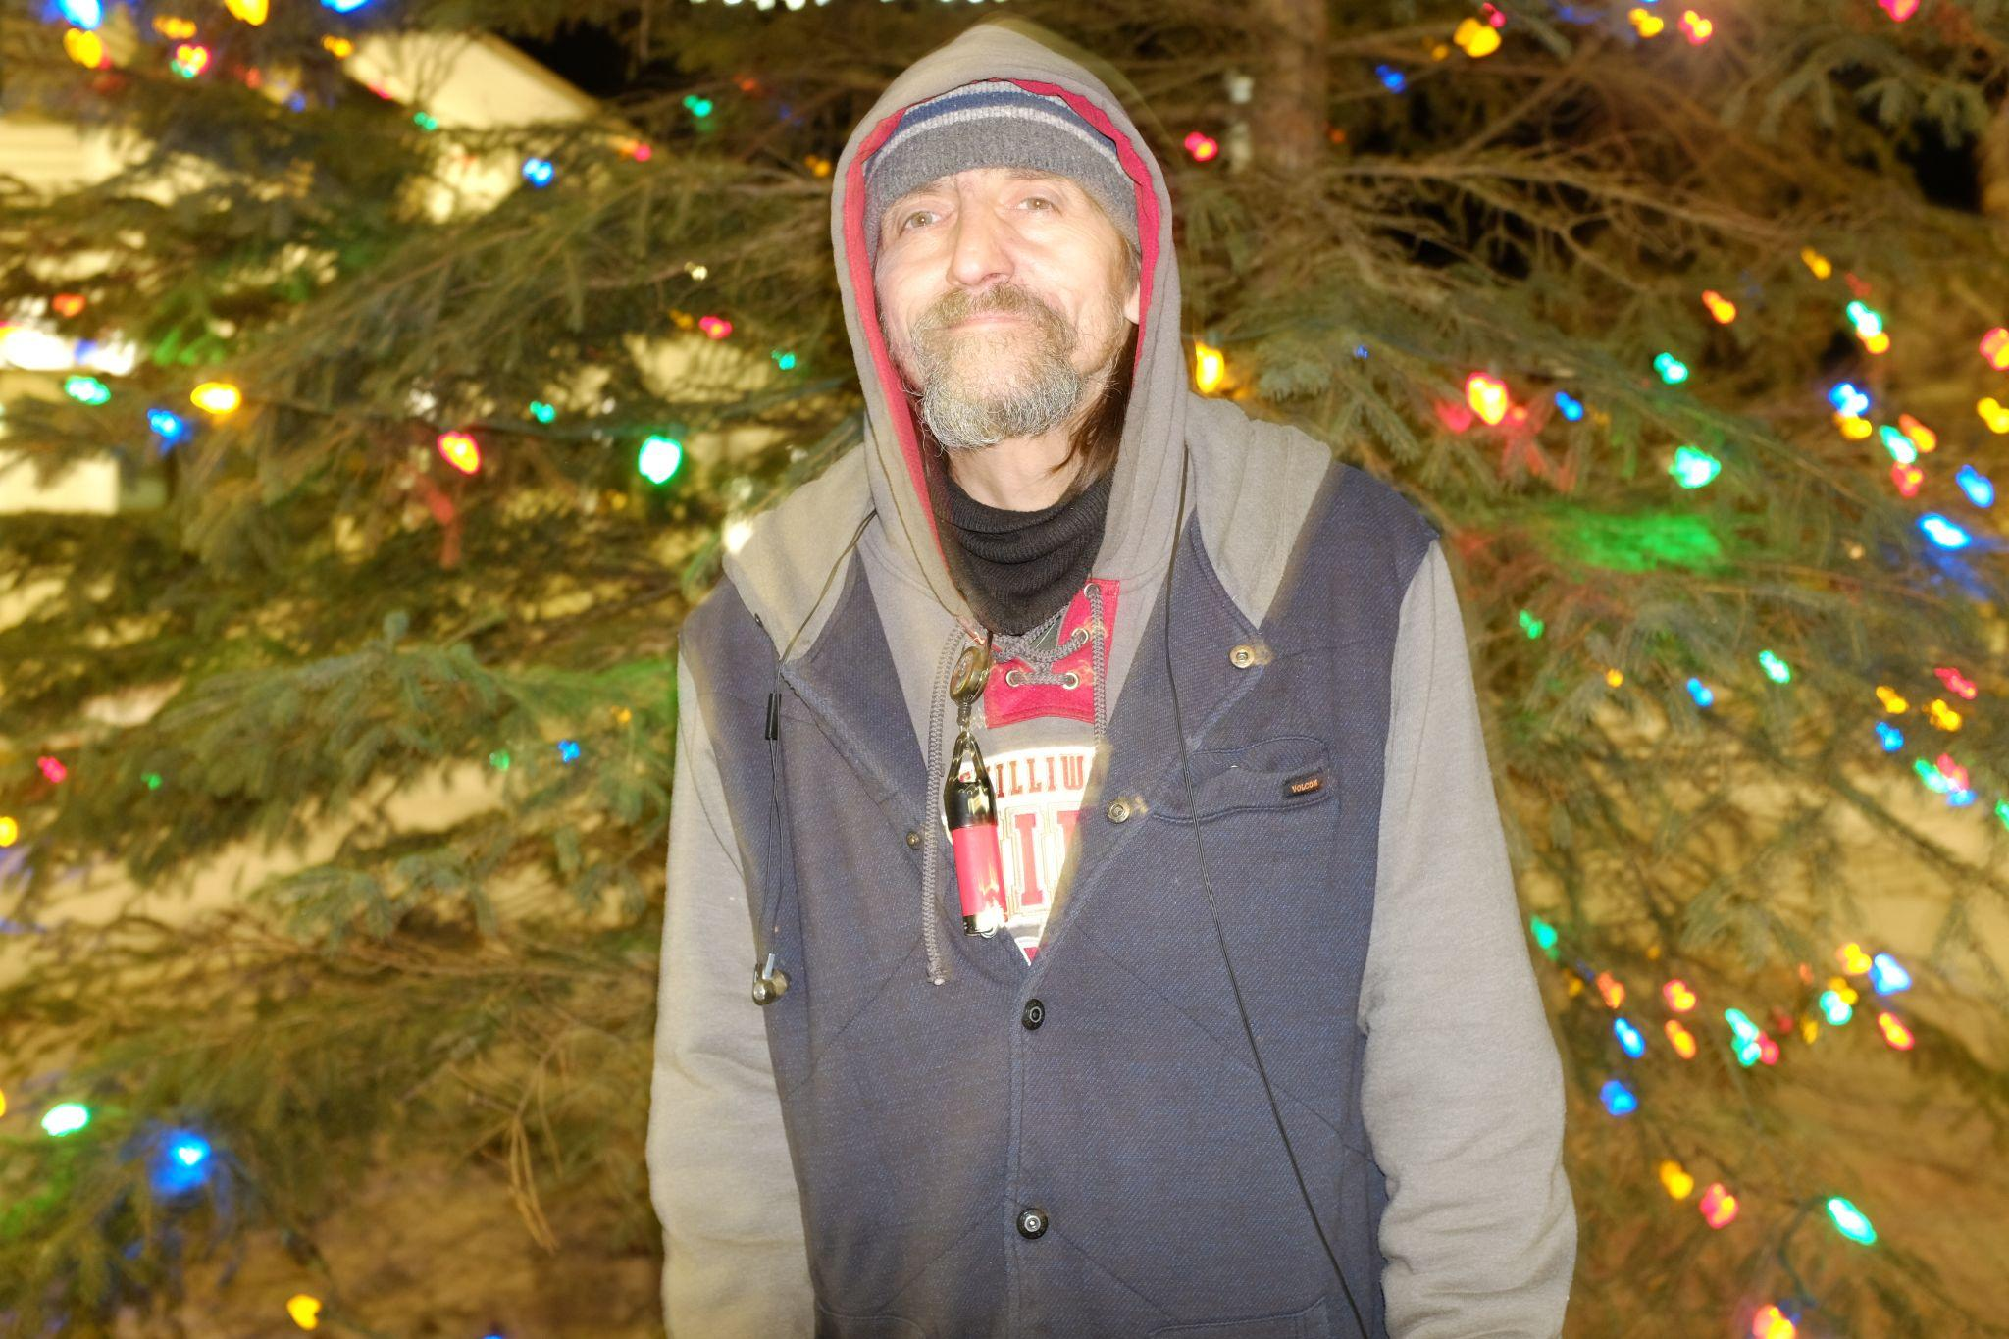

Gunner was someone who stood out to me the first time I met him. Quiet, reserved, soft-spoken. Maybe that was a strategy to come off soft in a world of hard ground, whipping winds against a tent wall, and the stigma that is cast on you as someone living homeless.

He works on himself slowly. He’s a fixer — always has been — and perhaps he is his own latest project. What does he want to work on now? Maybe buffing some rough spots, removing broken parts, or chafing any unnecessary weight to be a leaner machine.
Pam Haasen - so, I guess, just kind of taking away the things that we typically feel like describe ourselves, like things about age, name, etc. But who do you feel like you are at your core?

Gunner - Um, quiet person, you know, nice person, like to help others.

PH - Yeah, I noticed that about you, I think that you do help other people a lot.

G - Yeah, maybe, maybe I can do it more, and maybe, uh, in different ways or something, I'm not really sure. Yeah. I like doing auto body. Fixing cars, rust, dents.

PH - What do you like to do for fun?

G- Um, camping. Hiking. Bike riding. Working on cars. Playing around with cars, yeah.

PH - What excites you?

G - Seeing other people smile. Even from across the room, you just kind of see them like, Oh, what is this? Oh, what's going on there? Yeah. I've seen them happy, I guess.

PH - On the opposite side, what scares you?

G - Um, I've seen people crying. I guess. You never know what you're going to hear if you know the person and you're not sure what's going on.

PH - So you seem pretty empathetic then, that like, someone's having a feeling and you kind of almost feel it too.
G - Yeah. For them, yeah. Or with them, I guess. Yeah. Yeah.

PH - Who do you take care of?

G- Who do I take care of? Right now it's basically Amily, I guess. Yeah.

PH - Do you feel like you've always kind of had the role of caregiver or is that something that you, like, that's sort of been thrust upon you?

G - My two older brothers, they were quite a bit older than me. They took care of me. Yeah. Yeah, and then my older sister, Diane, but then my little sister, Michelle, I would try and take care of her.

PH - Are you still in touch with her?

G- My two older brothers passed away and so did my little sister.

Ph - what's a change that you've felt happen to you as you've gotten older?

G - When I was younger I grew up wanting things and I kind of basically felt that I basically got everything that I've ever wanted. You know, except for the big house, the wife and kids, but I got Amily, so that's a good start. (He looks to Amily and touches her hand)

PH - Yeah, that's sweet. How long have you two been together?

G - Going on four years.
PH - What is part of your daily life, like something you have to do every day or something that happens every day that you would like to change?

G - Um, probably the cigarettes. You know, the drugs we use, um… living in a tent, not having a job.

PH - Yeah, do you miss the routine of a job?

G - Yeah, it was, it was nice. When I looked at my mom's property in the backyard, I had my fifth wheel I lived in outside. So, I built a shop with my older brother, and I worked out of that shop.
I’d go out and find the work, bring it in, and paint cars, and I spent 20 years in there. Yeah, I did really good, I bought a lot of the things I ever wanted, working in that little shop. Yeah,
It was fun, make a lot of people happy, and you know, you do what they want, how they want it.

PH - You’re building and fixing things for people, so it's like making their lives a little bit better.

G - Yeah, yeah, yeah. I think it's just amazing how something could be done, mechanically.

PH - Were you always kind of mechanical that way?

G - Yeah, I guess, you know, well, when I was about 16 I started.

PH - What’s something that you’re proud of?

G - You know what I'm proud of? Um, my mom for sure.

PH - Would she say the same thing if I asked her, that she was proud of you?

G - She’d probably shake her finger, actually.

PH - What a mom thing to do!

PH - Do you make art?

G - I bought a guitar from my buddy Robert to help me with the basics of it.
And then, yeah, he started on his own and he sounds pretty good, so, yeah.

Amily (encouraging him) - You like drawing

G - Yeah, drawing is fun, yeah.

PH - Who are you when you're alone versus who you are in public?

G - Um, probably a lot quieter of a person. When I'm alone, just kind of go in on myself and just hope nobody knocks on my door.

PH - Yeah, you kind of have a real loner vibe about you. You're just a lone wolf.

(Laughing) G - Yeah, I listen to music and draw or whatever.

PH - When people see you, how do you normally steer interactions? Like, do you let them take the lead?
G - Yeah, yeah. If they want to talk, they'll come and say something or nod their head or whatever. You know, I always mind my own business, not look towards them, that's just, everybody's different and you don't know who you're going to run into or look at, just simple looking at somebody will sometimes get you in trouble in weird ways, like, oh wow, holy smokes.

PH - I feel like that kind of happens a little more in the city, do
you feel like that still happens quite a bit here too?

G- Oh yeah, for sure, yeah, yeah. But, you know I still smile, and hold the door open for people.

PH - how do you prepare for winter?

G - Just make sure you've got lots of warm clothes, warm blankets. Tarps to cover your tent and the thing ain't gonna cave in on you if you get a heavy snowfall when you're sleeping. Yeah. Candles. Cause it doesn't take much to actually heat up, get your heat back when you go under the covers with a little candle and it heats up on the earth really fast, really nice.

Amily Tom
36
Excellent at splitting and hauling wood (used to help her dad prepare wood for the family stove)
Born in Smithers, moved away to Prince George with her mom, graduated from high school in 1999 and then moved back to Smithers
Worked as a chambermaid at Esther’s Inn for 6 years

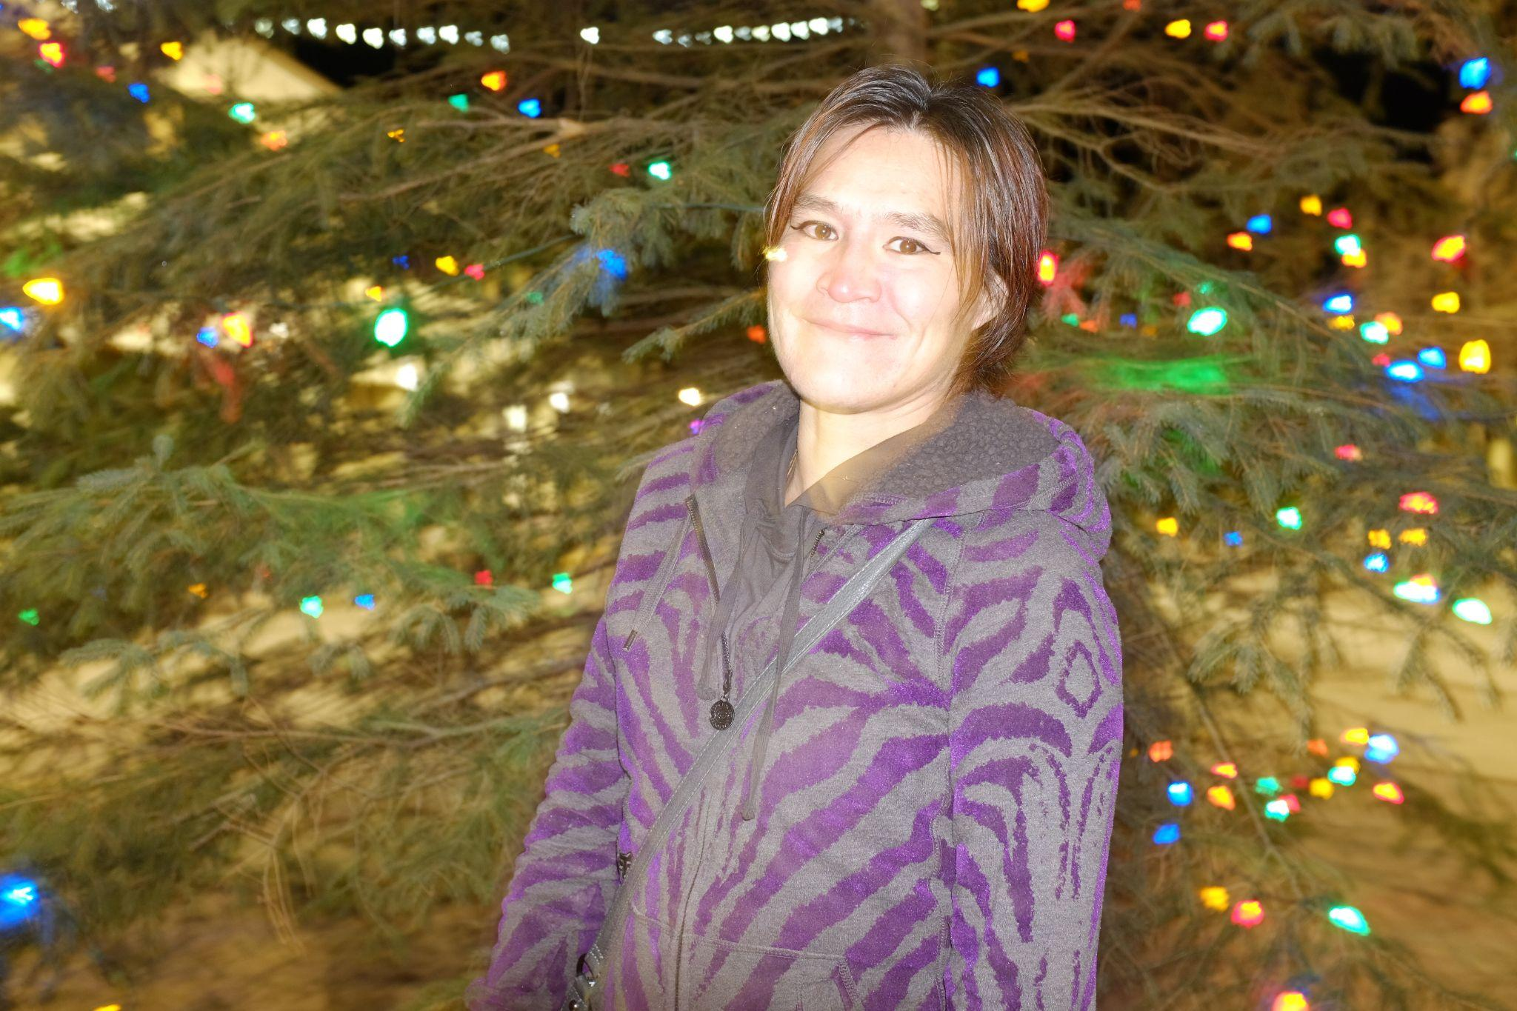

Amily is quiet, reserved, would rather enjoy quiet, outdoorsy activities or peaceful colouring than large, social activities. A total sweetheart, once she knows you, she’ll make a point to wave and ask you about yourself, whatever she knows of you, she remembers. It’s a very special gift only a few people have.

Pam Haasen - what is something that you are proud of?

Amily Tom - I'm proud that I graduated from school. And I used to take care of my sisters when they were younger because my mom wouldn’t. I’d work at Esther’s Inn (as a chambermaid), and I liked to take them out to go shopping and then they'd just run off and I'd tell them to get whatever they wanted.
And they were just all happy and, yeah, got whatever they wanted. And I told them I didn't care how much it cost. I was like, just grab it. And I'll pay for it whenever they're ready to come up to me. When they're happy, I like seeing that.

PH - Do you get along well with your family?

AT - Yeah. Yeah, I do.

PH - Do you have a big family?

AT - Um, yeah. Kind of. Yeah. Um, my dad is Eddie Pete. And my mom passed away like two years ago. Yeah, on my dad's side we were a big family.

PH - Is there anyone that makes you, like, that gives you strength that you feel like you rely on?

AT - That’s my dad and my boyfriend. Yeah.

PH - How did you two meet?

AT - My brother introduced us.

PH - Was it like at first sight?

AT - Yeah. I believe in love at first sight. Yeah. No. I love him.

PH - So, because you're pretty shy, do you feel like people like misinterpret that?

AT - I don't really kind of care what they think about me, but, yeah, it doesn't bother me none.

Sid Dennis
Age: 41
Lived in Smithers his whole life
Has family all over the north — Witset, Terrace, Hazelton, Prince Rupert, Vancouver, Edmonton, Whitehorse, everywhere.
Likes his tea this way: Orange Pekoe with 2 sugars and 3 honeys.

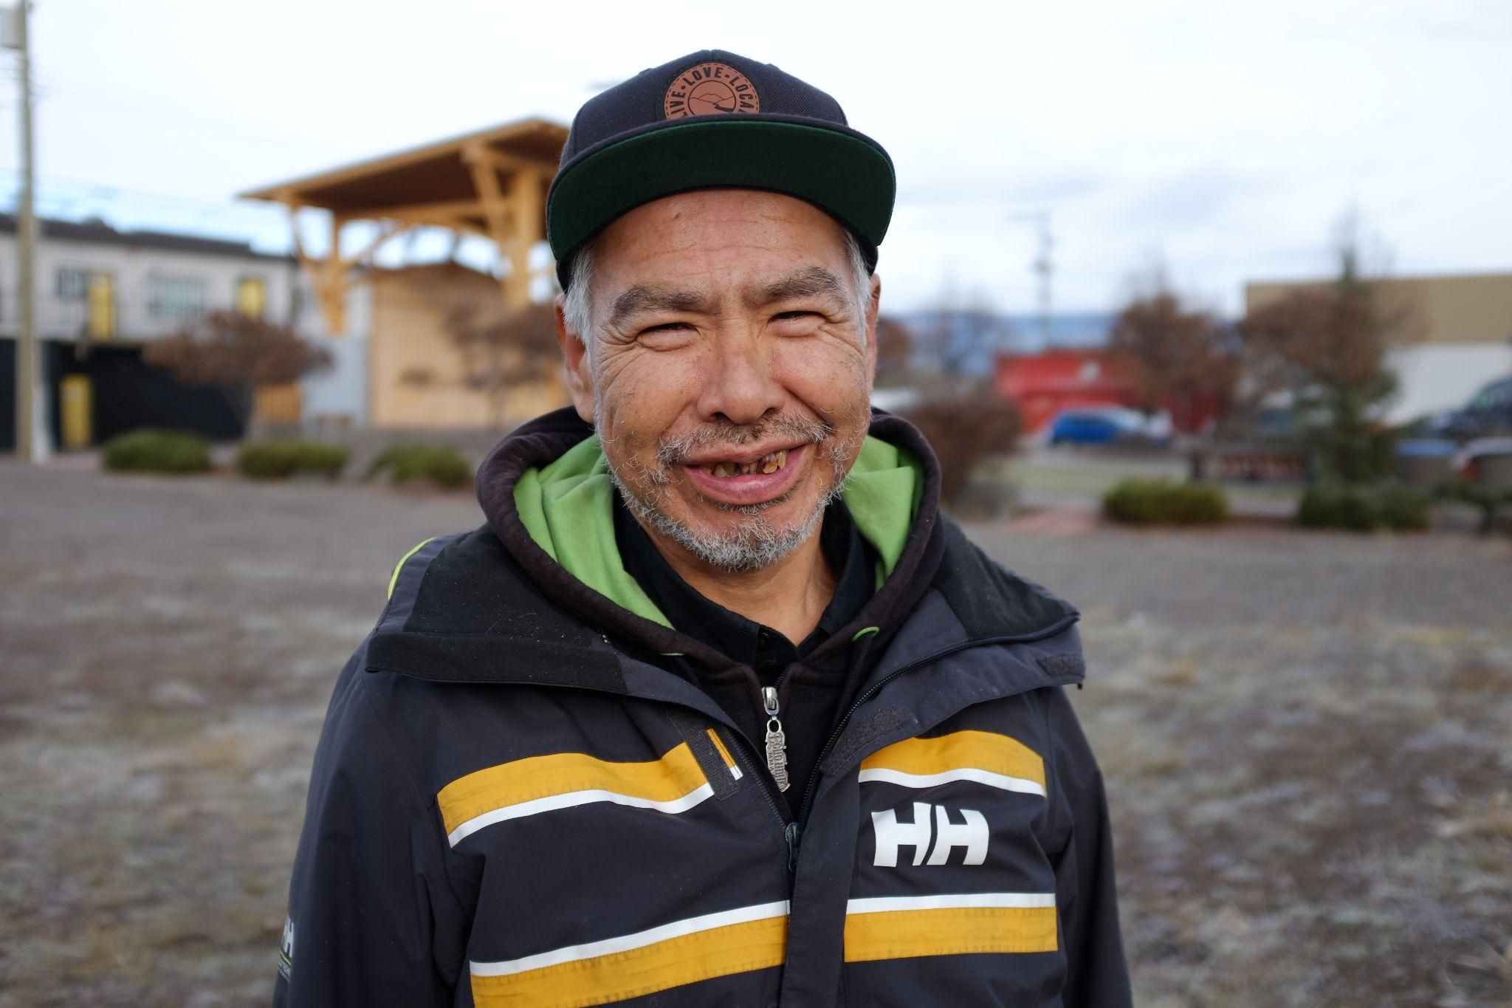

Last summer, Sid’s house on Princess Street caught on fire. He was in the house when it happened and he was the last person out of the house because he sacrificed his own safety to make sure everyone (and the cats) were out of the burning house.

He really doesn’t talk much about it, but rather has moved on to focus on getting his insurance and rebuilding when he can.

Pam Haasen - Where do you fit in, in your family's fabric? I know that you said you're the youngest in your immediate family, but where do you feel like you fit in, or what role do you play in your family?

Sid Dennis - Keep the smile on everybody's face. Everybody's surprised I walked out of that fire. The house. Thought I was a ghost when I came out of the hospital. I'm feeling better now.

PH - So we kind of have ways that we think of ourselves or describe ourselves. How do you describe yourself or think of yourself?

SD - I describe myself whenever I get hurt from other people. It don't bother me. I do heal myself once in a while, but I try not to hurt myself.

PH - Do you think it's to a fault that you're so forgiving?

SD - Well, I'm trying to do the change. I'm not trying to move backwards, I wanna move forward.

PH - would you describe yourself as an artist?

SD - I like doing native art and I've been doing it since I was 12. I never stopped. I do the pictures. I just give them away. I don't ask for money. Don't need money. People just give me money. I'm not worried about it. Everything's going good, slowly. Just gotta straighten my elder brother out.

PH - Where’s he?

SD - He’s going to go back to treatment.

PH - Do you feel like you're pushing people to better themselves?

SD - With Casey, yeah. Yeah. Because you don't see what's left of us. (Pause) But I do.

PH - So, you do spend a lot of time thinking about and doing things for other people, but what excites you and what do you hold kind of precious or something that's really important as a value for yourself to be happy?

SD - I just like to see smiles on everybody's face.

PH - What scares you?

SD - Too much family dying. (Long pause) That’s what scares me.

PH - Sid, it's got to be a lot of pressure to hold everyone together. And it seems like you also hold onto other people's pain too.

SD - I’ve just got too much anger in me.

PH - Anger because your family is falling through the cracks of being taken care of, or because you can’t take care of everyone yourself?

SD - I do it all on my own.

PH - Do you ask for help?

SD - I do. Not many people want to help me. Except my friends and people up on Princess Avenue. My old teachers, they help me out.

PH - you suffered a big loss when your house burned, and now you’re having to go through permits, and legal stuff. Are you getting help for that or are you doing that on your own?

SD - I’m doing it on my own, but one thing a day. I’m just trying not to rush myself, because you gotta plan these things out. That’s what my parents did, they planned everything and so I’m trying to do everything my mom taught me.

PH - How do you keep her memory alive, or what did she impart in you that you just feel is sacred and something that you keep for yourself?

SD - She taught me a lot of things. She taught me to move on, forgive, taught me to take care of myself…

PH - Did she teach you to love people the way that you do, so selflessly?

SD - Yeah. My mom and my dad, my grandma and grandpa, they taught me. My parents raised me too good. Never had the guts to go see the grave though. I’m just not ready for that. I have to move forward, but I have a lot of stress on my back. I try not to let it bother me because I’ve learned to control my anger. It took me 12 years to control, and I’m still working on it.
That’s why I go for so many walks. My mom said “if you’re angry, go for a walk, come back, you’ll be nice and calm”, and I’ve been doing it my whole life. People want to tell me I’m mad, but how can I be mad for long? You can’t let things bother you for that long and I like to be happy.

PH - Yeah, but you’re human too, you’re allowed to feel your feelings fully and completely without having to protect everyone else’s feelings.

SD - Yeah, it’s mostly the family I protect. My friends. I’m pretty overprotective of my family. When I meet all my cousins’ boyfriends, I give them warning: “You hurt their feelings, I get a phone call, I come down and hurt you”.
But if I don’t get any calls, I’m sure they’re ok.

PH - When you're alone, are you doing a lot of thinking about other people? Or is that when you can finally think about yourself?

SD - Oh, I’m thinking of others, and myself at the same time. You can’t separate the two. You have to do it all together.
It’s like my native art, I don’t do it to keep for myself. I do it to give it away and I don’t want money for it.

PH - what does your art mean to you, and why do you feel the need to create?

SD - My art keeps me calm. I always have to keep my hands busy. If you don’t keep your hands busy, you’ll find yourself back in that hole again. Nobody wants to go to that hole. I’ve put myself in there so much, it took a while for me to get out. And I’m only halfway out.
I put my life on the line for Smithers. I stay out all night once in a while, go see my friends, watch a movie, get stoned…I’m slowly working on quitting my smoking. It’s kind of hard to do, taking it one day at a time because my mom wanted me to quit smoking. It’s hard though I’m trying my best. I’ll get through it.

PH - It sounds like you’re navigating a lot of systems though.

SD - Yeah, maybe too many. It’s well worth it though, because I’ve got a big family and friends, and I want to do it all for them. You do whatever your calling is. That’s mine.”

PH - When these interviews are done, we’ll turn these into a zine with your interview, and some art. But if someone were to pick this up and read it, do you have a message that you want to tell people?

SD - Not really, just that people need to keep trying to move forward instead of backwards. You’re hurting yourself if you’re not moving forward, so get rid of your problems first, gain your energy back and move forward in life.
I do that through my art, and talk to my friends. That’s how I keep ticking

Jessica Wilson

The following piece was submitted to Voices Carry by Jessica Wilson in 2024.
It was written in 2023

My name is Jessica, I am 29 years old. I’m a recovering alcoholic/addict. I am a few weeks shy of my 3 years sober. No one ever talks about how hard sobriety is, especially when you have years and years of trauma, anger and grief.
I’ve been drinking since I was 13 years old. It’s just always been a part of my life and I thought it was normal because my parents struggled and everyone around me did. So, most of my life I thought it was OK. I never realized how much me and my siblings suffered while my parents partied around. I thought every other kid was at home with no food too. I thought it was normal for parents to leave their kids alone for days and weeks at a time with no food.
I just left an abusive relationship and moved back home to beautiful Smithers BC. Not long after I moved home, like a few weeks after, I lost the only parent that gave a damn about me and my siblings, the Wilson Kids. Just like that he was taken. That’s when booze really took over and I was on a self-destructive war path. I hit the bottom of the barrel quick, in and out of the hospital, liver problems, kidney problems, having an emergency surgery for my gallbladder. Even that didn’t stop me. My esophagus was burnt from all the vodka I drank day in day out.
At the age of 26 my doctor told me I wasn’t gonna see 27. At 26, a doctor is telling me this. At first my thought was ”who’s gonna miss me?” Not long later I found out I was pregnant with my youngest baby. I stayed drunk for one more week and quit cold turkey. Detoxing was hard., I don’t miss going snakey. Don’t miss the shakes. These three years I’ve been sober I lost all my friends and some family, including my baby brother, to substance abuse. My little brother was 26 years old, still a baby. He passed alone. I stayed solid through his passing. I stayed sober. This is like a tribute to him and my kids. Breaking cycles, stopping generational trauma. I always say addiction ran in my family ‘til it ran into me.
Nobody talks about how hard and painful it is breaking cycles. It should be brought up more often. I’m going through all this pain I ran from for so many years so I’m not handing it down to my kids. Every hit life has given me I wasn’t down for long.
For as long as I could remember alcohol has always been a part of my life. When I was a young girl, I’d see my parents party. All the time they’re drinking would start off having the time of their life laughing, singing, slowly turning to fighting and smashing the whole house up as my and my siblings cried, wanting to be somewhere else safe. I was about 13 when I had my first drink. First it started out as just drinking to have fun with friends, then it started out as enjoying being num. Numb from trauma, numb from emotional abuse.
I always wondered why I struggled so bad with my addiction. It felt so good to be numb in the moment, to not feel sadness, anger, loneliness, trauma from the 30 years on earth. Grief from all my traumatic losses. The very first time I witnessed someone under the influence was scary. I was probably 4 or 5 and I remember looking at my siblings thinking ‘this is scary, we need to get this guy some help’. That night we huddled in our parents’ room under the blankets. As I got older, seeing my parents party was not even a big deal anymore, it was just like ‘alright, here we go again’.
With their parties always came fighting, screaming, crying, and to me this was normal. I thought every other kid in my school went through this. I remember telling my classmate “Last night was crazy, I didn’t get much sleep. My parents partied all night. There was blood everywhere.” The shocked look on their faces told me that this was not normal.
Growing up in such a toxic household has really taken its toll on me. My very first sip of booze was at 13. There I was 13 years old partying with 20- and 30-year-olds. I dropped out of school. I always showed up hungover and couldn’t concentrate.
I wish I stayed in school. Biggest regret of my life. After I dropped out of school I became homeless at the age of 13. That brought up a lot of anger, sadness, and the feeling of being unwanted by the same people that are supposed to love me and help me grow. Although I didn’t have family, I made friends with people who became family, who are still a part of my life to this day.
The neglect from my family led to years of drinking, for the next 14 years. Being a young vulnerable girl, drinking got myself into scary situations., some I wondered how I got out of alive.
I remember after the biggest loss of my life, that’s when my drinking took over. I couldn’t stop no matter how hard I tried. I couldn’t go a day without drinking, even when I knew my body couldn’t handle any more. I’d drink ‘til I couldn’t or ‘til I didn’t remember.
I remember having to go through surgery and my surgeon asked me how much I’d drink in a day. He was shocked at my response. He said, “How are you still standing?”
At the age of 26 I was told if I kept drinking, I wouldn’t live to see 27. I thought my life has been filled with so much hate and sadness, why would I care or anyone else care if I passed.

I thought of Johnny, and knew he needed me as much as I needed him. I remember praying to God to give us a miracle that we’d quit drinking. Give us a reason to live. A few days later, I found out I was pregnant.
We have a family. We’re breaking the cycle for the girls. They are worth it, although I do struggle and feel I always will until I deal with all my trauma, all my grief, that’s holding me back. ‘Til that day, I’ll take it one day at a time.

Voices

Sid Dennis
Warren ‘Dubz’ Wilson
Amalie Tom
Wayne ‘Gunner’ Suvee
Jessica Wilson (submitted piece)

Interviews by

Pamela Haasen

Funding for Voice Carry by
SPARC BC

